|  |  |  |  |  |  |
| --- | --- | --- | --- | --- | --- |
| Date | 13-Dec-22 | | | Tester Name | Andrew McLaughlin |
| Environment | Penfax - Test | | | Login used |  |
| Operating System | Windows | Version: | Update: | | |
| Software Used | Select Software | Version: | Update: | | |
| Select Software | Version: | Update: | | |
| Release version | 22.4.1 | | | | |
| Title | V5 1.06 Viewing and Updating Verification Icons | | | | |
| Test Type | Regression | | | | |
| Test Scenario | V5 1.06 Viewing and Updating Verification Icons | | | | |
|  |  | | | | |
| Expected Results | We should be able to see unverified people, add verification status, and see verification flags update | | | | |
| Pass/Fail | Pass | | | JIRA# | N/A |

Describe your steps with screenshots:

Open up a member’s file and view the existing verification flags under Person Profile 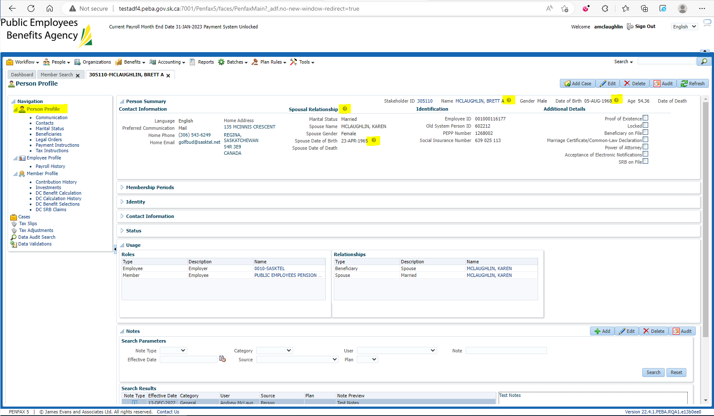

Add verifications to each flag by clicking on the ? icon and hit Save 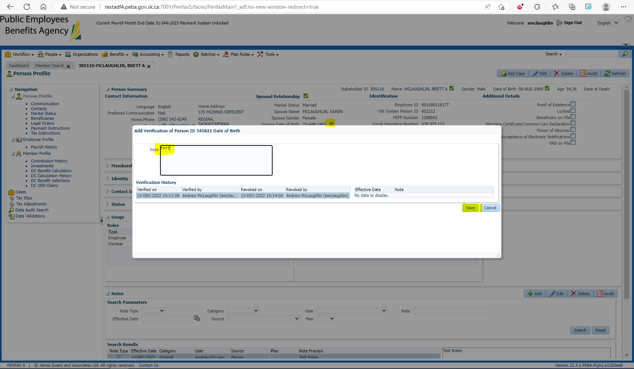

Ensure verification history is populating 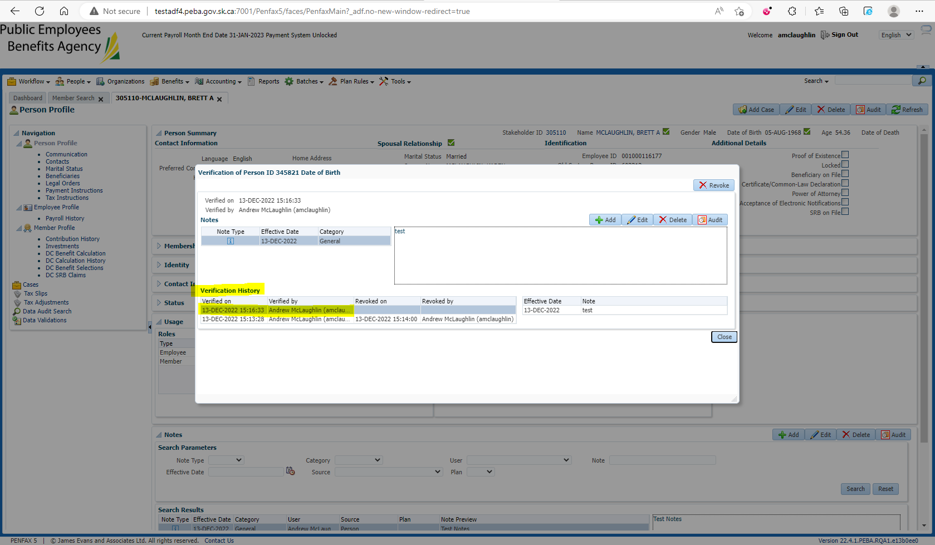

Ensure that after verifying, all the ? change to check marks 